Changes document for MS Decom activities

Project: z_i740_sin_reg

System : xFE

CD: 151938.

Transport request: DFEK962733

—---------------------------------------------------------------------------------------------------------------------------------

1. Added new button to download gsheet in master view.xml

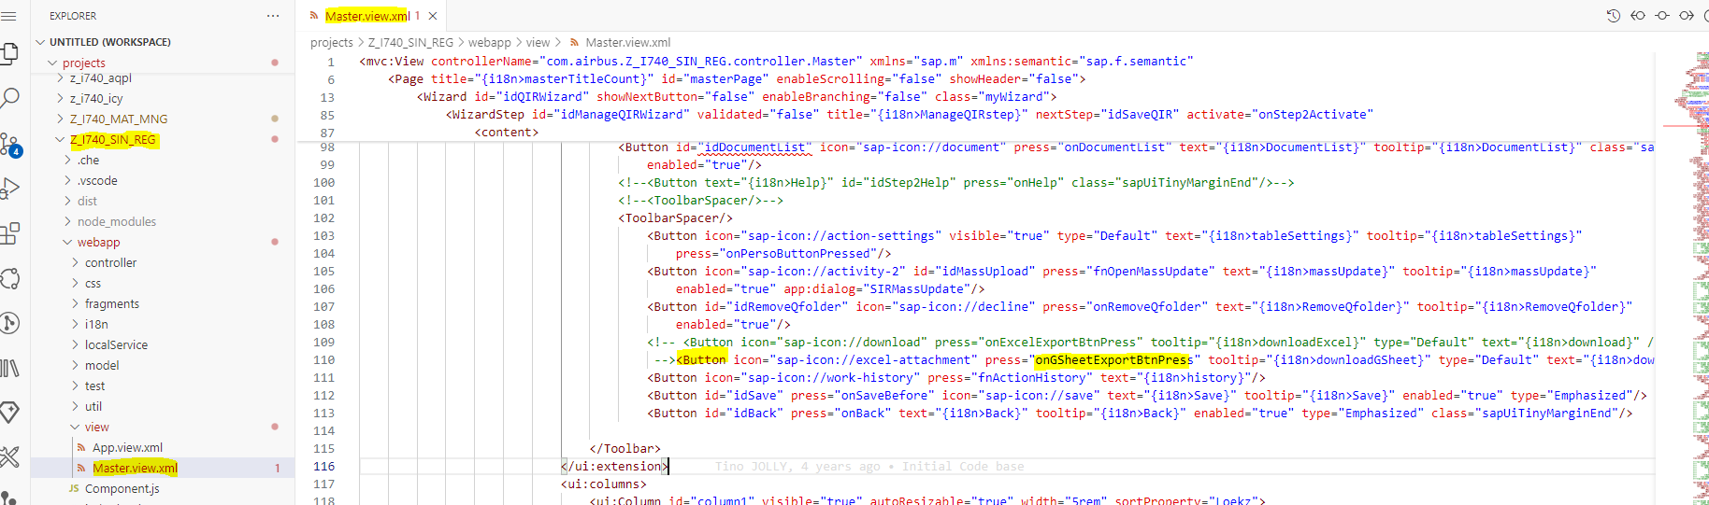

1. In controller added logic to load gsheet based on the filters, selected columns.

